**Sri Lanka Institute of Advanced Technological**

**Education**

**(SLIATE)**

**A proposal on**

**Smart Dustbin with IOT Notifications**

**Summited by**

**N.Daniel Abarajithan**

BAT/IT/2018/FT/0043

**Supervised by**

**Mr. T.Mathanaruban**

**Mr.K.Thevaruban**

**Table of Contents**

1. Introduction 3

2. Background and Motivation 4

3. Problem in brief 5

4. Aim &objectives 5

4.1 Aim 5

4.2 Objectives 5

5. Proposed solution 6

5.1 Planning 6

5.2 Analysis 6

5.3 Design 6

6. Requirements 7

7. Resource Requirements 8

7.1 Software Specifications 8

7.2 Hardware Specifications 8

7.2.1 Arduino uno 9

7.2.2 Ultrasonic Sensors 10

7.2.3 Mic Sensor 11

7.2.4 Wi-Fi Module 11

8. References 12

# 1. Introduction

This project proposal is submitted” to meet the requirements of the Individual Project module conducted by the” Sri Lanka Institute of Advanced Technological Education (SLIATE), 2020.

Today main issue for pollution is Garbage Overflow. It creates unhygienic condition for the people and creates bad smell around the surroundings this leads in spreading some deadly diseases & human illness. To avoid all such situations, I am going to implement a project called smart dustbin with IoT notifications. Implementation is done with the help of IoT concept. The Internet of Things (IoT) is a concept in which surrounding objects are connected through wired and wireless networks without user intervention

Dustbins are small metal (or plastic) containers that are used to store trash (or waste) on a temporary basis. They are often used in homes, offices, streets, parks etc. to collect the waste. In some places, littering is a serious offence and hence Public Waste Containers are the only way to dispose small waste.

Usually, it is a common practice to use separate bins for collecting wet or dry, recyclable or non-recyclable waste.

In this project, I have designed a simple system called Smart Dustbin using Arduino, Ultrasonic Sensor, where the lid of the dustbin will automatically open itself.

# 2. Background and Motivation

With increase in population we have an increase in the garbage around urban areas. Here we propose a smart dustbin that operates automatically to help solve this issue using IOT and sensor-based circuitry. Usual dustbins require to be opened by pressing foot against its lever and then throwing garbage. Also, a person needs to keep track when it is full so that it can be emptied and does not overflow. Here I propose a smart dustbin that does all this by itself.

My system consists of a sensor in order to detect human clap signal it opens automatically without anyone needing to press its lever. The dustbin opens automatically when it receives the signal and closes its hatch. Also, the dustbin consists of a level sensing ultrasonic sensor that constantly measures the level of garbage in the bin and automatically detects if it is about to fill up.

This bin is of a vast usage in offices, homes and even in public places for garbage management. Thus, I get a fully automated smart dustbin that allows for automated garbage cleaning.

# 3. Problem in brief

Foul smell from these rotten wastes that remain untreated for a long time, due to negligence of authorities and carelessness of public may lead to long term problems. Breeding of insects and mosquitoes can create nuisance around promoting unclean environment. This may even cause dreadful diseases.

To avoid all such situations smart dustbin that allows for automated garbage cleaning.

# 4. Aim &objectives

## 4.1 Aim

Smart dustbin helps to solve the problems related to the garbage management. This project aims at developing the affordable smart dustbin using IOT and sensor-based circuitry. The concept is very simple and easy to use. The major need of a smart lifestyle begins with cleanliness and cleanliness begins with dustbin. A society will get its waste dispatched properly only if the dustbins are placed well and collected in well prepared.

## 4.2 Objectives

In this project is to design and build a prototype for an automatic open dustbin that can automatically open the lid when it detects the people who want to throw out their trash.

It also can detect the level of the trash that inside the dustbin.

Waste Management is all the activities and actions required to manage waste from inception to its final disposal. So, this can be done by implementing IoT based waste management using smart dustbin.

# 5. Proposed solution

The main concept behind the Smart Dustbin using Arduino project is Object Detection. I have already used Ultrasonic Sensor, where upon detecting an object where the

Ultrasonic Sensor is placed on top of the dustbin’s lid and when the sensor detects any object, it will trigger Arduino to open the lid.

## 5.1 Planning

In this case, the objectives and goals of the projects are to improve the process in waste handling. Identify the tools that going to use in the development process.

Methodology:

In this project methodology model takes the fundamental process activities of Project Plan, specification, Analysis, Design, development, validation and evolution and represents them as separate process phases. Using a waterfall model as a project development methodology.

## 5.2 Analysis

This phase includes identifying the tools, the functions of the project, and the requirements for the project.

## 5.3 Design

The system design tries to be cost-effective and user-friendly. The Controller employed here is the Arduino unit that receives the measurement signals from the sensor units and in turn sends command signals to the concerned authorities for the requisite actions to be taken for effective solid waste management.

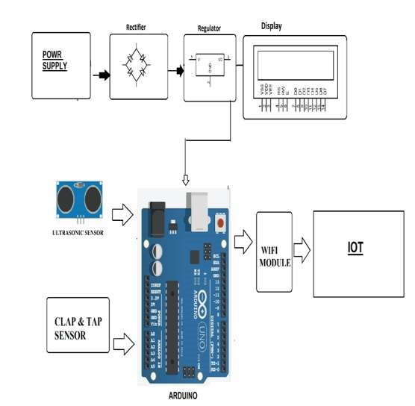

*Smart Dustbin Block Diagram*

# 6. Requirements

* Sensor detect human clap signal it opens automatically without anyone needing to press its lever.
* Sensor that constantly measures the level of garbage in the bin and automatically detects if it is about to fill up.
* The dustbin consists of a smart circuitry that transmits information over the web to signal the main garbage collector of the facility to empty the particular garbage bin.

# 7. Resource Requirements

Smart bin is built on Arduino board platform. The resources that are needed to complete the project.

# 7.1 Software Specifications

Arduino Compiler

Programming Language: C

IOTGecko

# 7.2 Hardware Specifications

* PCB and Breadboards
* Arduino Uno
* LED
* Ultrasonic Sensor
* Transformer/Adapter
* Mic Sensor
* Push Buttons
* Wi-Fi Module
* Switch
* Resistors
* IC
* Capacitors
* IC Sockets
* Transistors
* Bin Frame
* Cables and Connectors
* Mounts & Joints
* Diodes
* Supporting Frame

### 7.2.1 Arduino uno

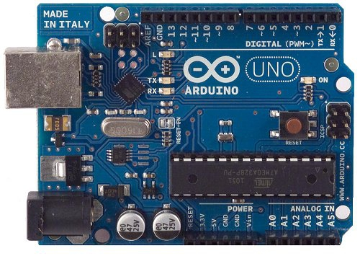

The **Arduino Uno** is an [open-source](https://en.wikipedia.org/wiki/Open-source) [microcontroller board](https://en.wikipedia.org/wiki/Microcontroller_board) based on the [Microchip](https://en.wikipedia.org/wiki/Microchip_Technology) [ATmega328P](https://en.wikipedia.org/wiki/ATmega328P) microcontroller and developed by [Arduino.cc](https://en.wikipedia.org/wiki/Arduino). The board is equipped with sets of digital and analog [input/output](https://en.wikipedia.org/wiki/Input/output) (I/O) pins that may be interfaced to various [expansion boards](https://en.wikipedia.org/wiki/Expansion_board) (shields) and other circuits. The board has 14 digital I/O pins (six capable of [PWM](https://en.wikipedia.org/wiki/Pulse-width_modulation) output), 6 analog I/O pins, and is programmable with the [Arduino IDE](https://en.wikipedia.org/wiki/Arduino#Software) (Integrated Development Environment), via a type B [USB cable](https://en.wikipedia.org/wiki/USB_cable). It can be powered by the USB cable or by an external [9-volt battery](https://en.wikipedia.org/wiki/9-volt_battery), though it accepts voltages between 7 and 20 volts. It is similar to the [Arduino Nano](https://en.wikipedia.org/wiki/Arduino_Nano) and Leonardo. The hardware reference design is distributed under a [Creative Commons](https://en.wikipedia.org/wiki/Creative_Commons) Attribution Share-Alike 2.5 license and is available on the Arduino website. Layout and production files for some versions of the hardware are also available.

### 7.2.2 Ultrasonic Sensors

An ultrasonic sensor is an electronic device that measures the distance of a target object by emitting ultrasonic sound waves, and converts the reflected sound into an electrical signal. Ultrasonic waves travel faster than the speed of audible sound (i.e. the sound that humans can hear). Ultrasonic sensors have two main components: the transmitter (which emits the sound using piezoelectric crystals) and the receiver (which encounters the sound after it has travelled to and from the target).

In order to calculate the distance between the sensor and the object, the sensor measures the time it takes between the emission of the sound by the transmitter to its contact with the receiver. Ultrasonic sensors are used primarily as [proximity sensors](https://www.fierceelectronics.com/sensors/what-a-proximity-sensor). They can be found in automobile self-parking technology and anti-collision safety systems. Ultrasonic sensors are also used in robotic obstacle detection systems, as well as manufacturing technology. [In comparison to infrared (IR) sensors](https://www.maxbotix.com/articles/ultrasonic-or-infrared-sensors.htm) in proximity sensing applications, ultrasonic sensors are not as susceptible to interference of smoke, gas, and other airborne particles (though the physical components are still affected by variables such as heat).

Ultrasonic sensors are also used as [level sensors](https://www.fierceelectronics.com/sensors/what-a-level-sensor) to detect, monitor, and regulate liquid levels in closed containers (such as vats in chemical factories). Most notably, ultrasonic technology has enabled the medical industry to produce images of internal organs, identify tumors, and ensure the health of babies in the womb.

### 7.2.3 Mic Sensor

A microphone is a sensor or transducer which converts sound to electric signals. There are many types of microphones, but nowadays microphones are mainly divided into two categories: dynamic microphones and condenser microphones. Both types generate signals from changes in the air pressure. When the moving plate (diaphragm) vibrates in time with the sound wave, the distance between the plates and hence the capacitance is changed. The changes in capacitance can then be converted to an electrical signal. Since the diaphragm can be made extremely thin and light, its flexibility is extremely good and the signal is therefore of extremely good quality.

### 7.2.4 Wi-Fi Module

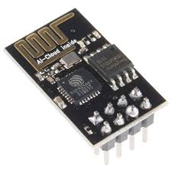The **ESP8266** is a low-cost [Wi-Fi](https://en.wikipedia.org/wiki/Wi-Fi) microchip, with a full [TCP/IP stack](https://en.wikipedia.org/wiki/TCP/IP_stack) and [microcontroller](https://en.wikipedia.org/wiki/Microcontroller) capability, produced by [Espressif Systems](https://en.wikipedia.org/w/index.php?title=Espressif_Systems&action=edit&redlink=1)The chip first came to the attention of Western [makers](https://en.wikipedia.org/wiki/Maker_culture) in August 2014 with the **ESP-01** module, made by a third-party manufacturer Ai-Thinker. This small module allows microcontrollers to connect to a Wi-Fi network and make simple TCP/IP connections using [Hayes](https://en.wikipedia.org/wiki/Hayes_command_set)-style commands. However, at first there was almost no English-language documentation on the chip and the commands it accepted. The very low price and the fact that there were very few external components on the module, which suggested that it could eventually be very inexpensive in volume, attracted many hackers to explore the module, the chip, and the softwar e on it, as well as to translate.

# 8. References

Kscst.iisc.ernet.in. (2020). [Online] Available at:

http://www.kscst.iisc.ernet.in/spp/40_series/SPP40S/01_Seminar%20Projects/053 _40S_BE_2142.pdf [Accessed 25 Feb. 2020].

Smart Bin. (2020). Smartbin | Smart Monitoring and IoT Waste Management | Smart City Solutions. [Online] Available at: https://www.smartbin.com/ [Accessed 25 Feb. 2020].

Electronics Hub. (2020). Smart Dustbin using Arduino, Ultrasonic Sensor & Servo Motor. [online] Available at: https://www.electronicshub.org/smart-dustbin-usingarduino/ [Accessed 25 Feb. 2020].